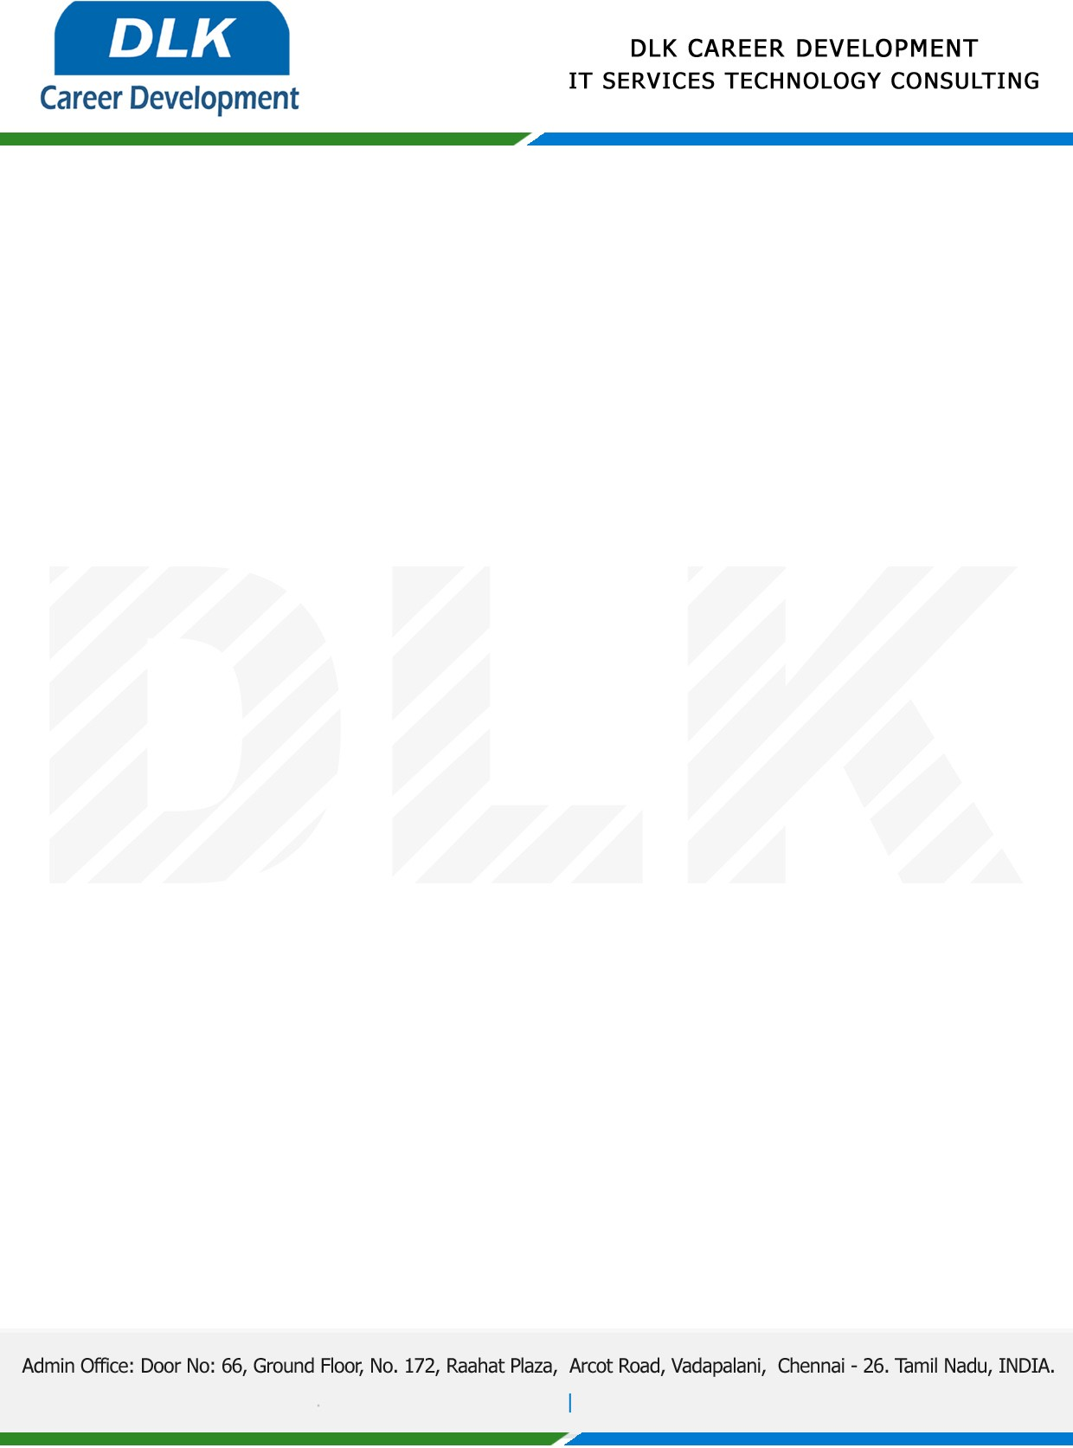

Date: 31/ December/ 2022

**To**

Department of BE (Computer Science Engineering),

Head of Department,

Panimalar Engineering College, Chennai- 600123.

**Sub: Letter of Internship Acceptance**

This is to certify that **MS ANNIE S (REG NO: 211420104019)** that third year student of has accepted her Internship Work duration from **02nd January 2023** to **07th January 2023** under domain **“Data Structure-Java”.** During the internship, all information and data collected from you should be kept confidential.

We appreciate your interest in **DLK CAREER DEVELOPMENT**

For **DLK CAREER DEVELOPMENT**

**HR Manager**

**VELMURUGAN J**